MARYLAND ELECTRICAL CONTRACTOR
AND INSPECTOR ASSOCIATION
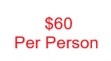
78TH ANNUAL SHRIMP AND BULL ROAST
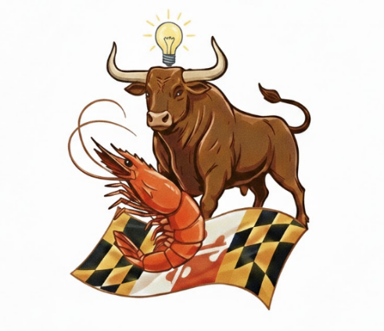
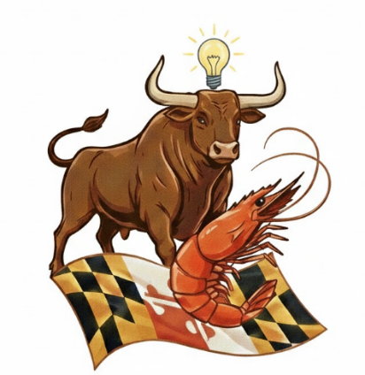
SUPERIOR CATERING
1010 OLDHAM STREET
BALTIMORE – MD - 21224
SATURDAY MAY 16TH, 2026
1:00PM -5:00PM
ALL YOU CAN EAT: STEAMED SHRIMP, TOP ROUND BEEF ON THE PIT, ROAST TURKEY BREAST ON THE PIT, BBQ CHICKEN LEGS, HOMEMADE MD CRAB SOUP, SHRIMP CREOLE, WHIPPED GARLIC POTATOES, SAUERKRAUT & KIELBASA, SEASONED GREEN BEANS, GREEK SALAD W/ FRESH FETA, HOMEMADE PASTA SALAD, HOMEMADE COLESLAW, ASSORTED DESERTS, DRAFT BEER, SODA, TEA, LEMONADE AND COFFEE
Live DJ – Silent Auction – Wheels – And More!
For more information visit our website or call 410-486-3549
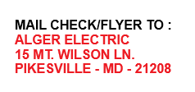

www.mdecia.org



